SIGNAL PROCESSING

LAB – 8 REPORT

Abhinav Marri

2021112015

**Question – 1**

**Given filter :**

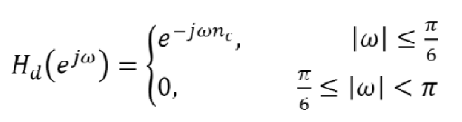

using I-DTFT to find the filter hd[n] and HLPF[n].

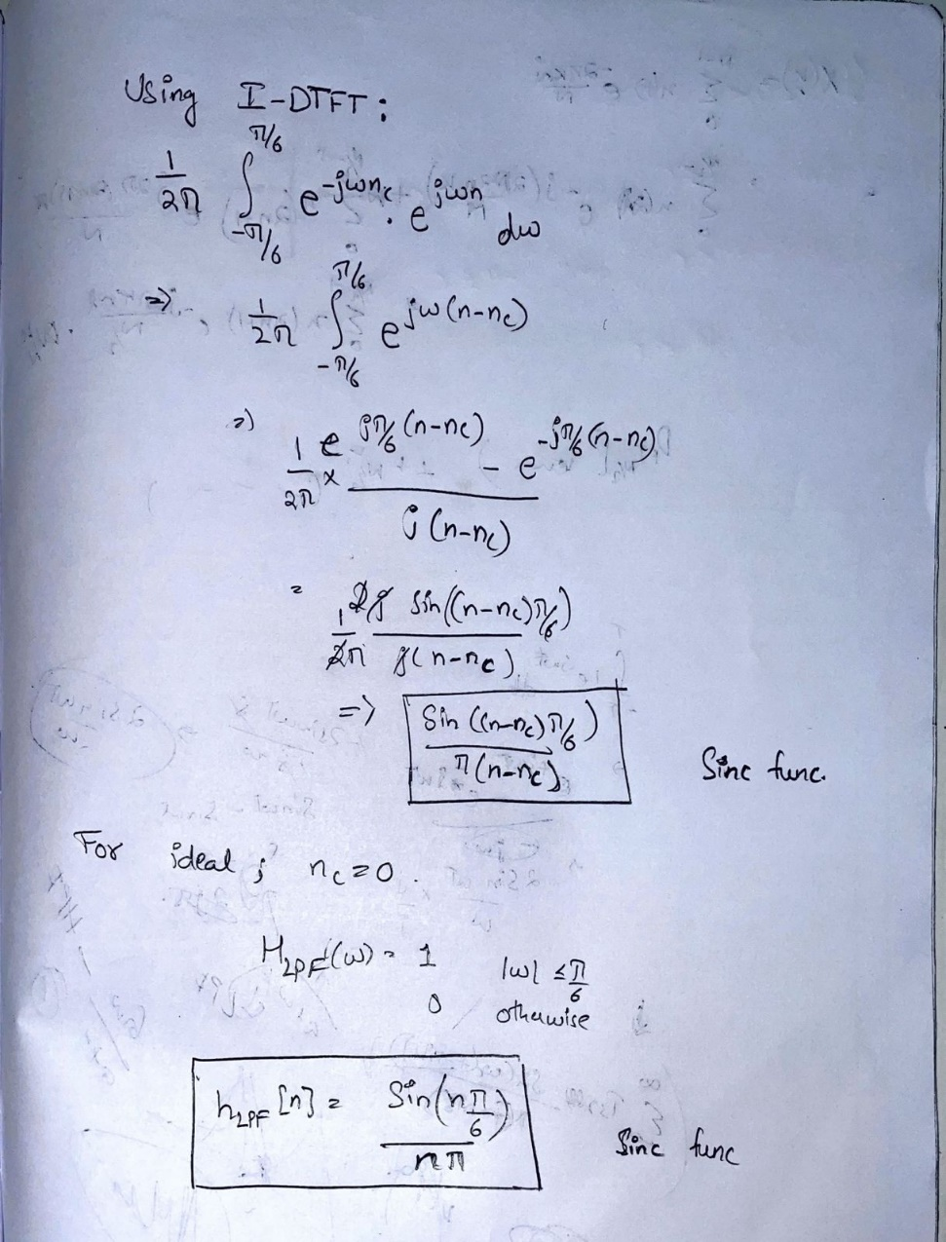

b) obtained 1001-point DFT :

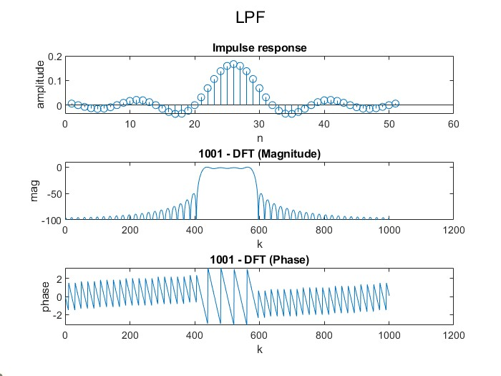

Observed magnitude response is that of a LPF. We can observe linear phase from the plots.

C) *Blackman window :*

* The Blackman window is a taper formed by using the first three terms of a summation of cosines. It was designed to have close to the minimal leakage possible.

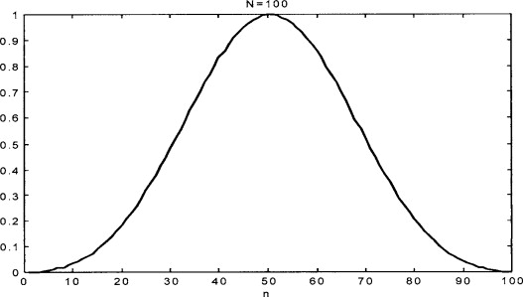

*Fig : Blackman window*

Using a blackman window :

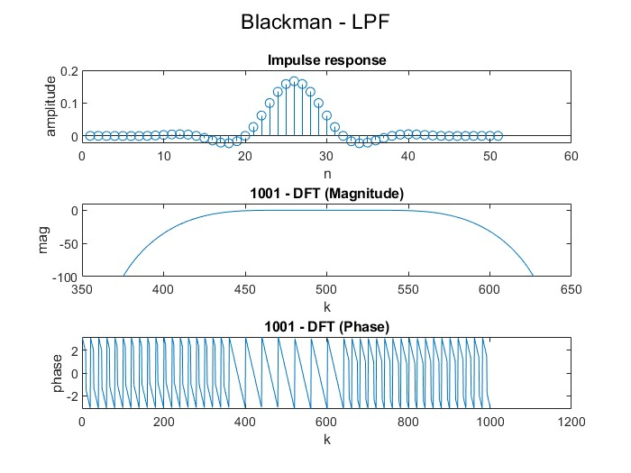

d) The Blackman window ends up giving us a better result.

* The transition band width is higher for the blackman window than compared to that of the rectangular window.
* The side-lobe levels are lower in the blackman window which is desired and allows for better blocking out of frequencies.

e) filtering the given signal using the filters we just made :

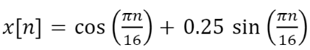

Filtering :

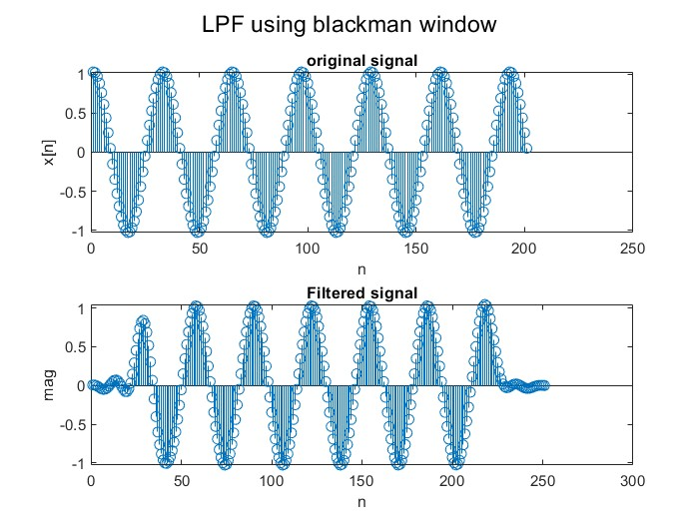 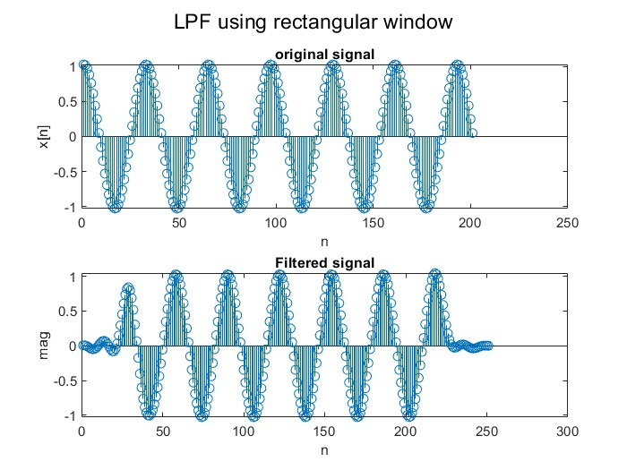

Doing the same for the following signal :



Filtered signals:

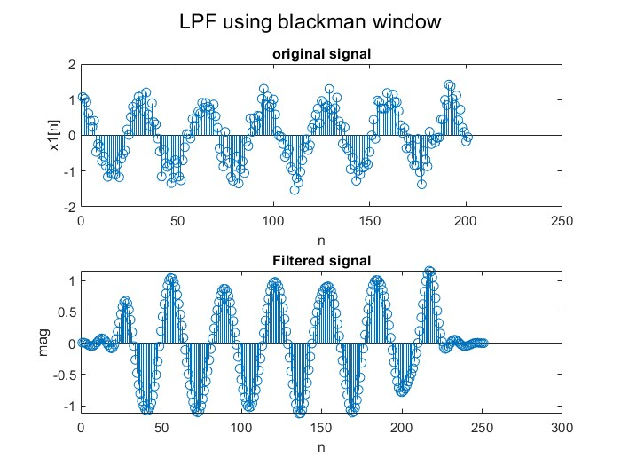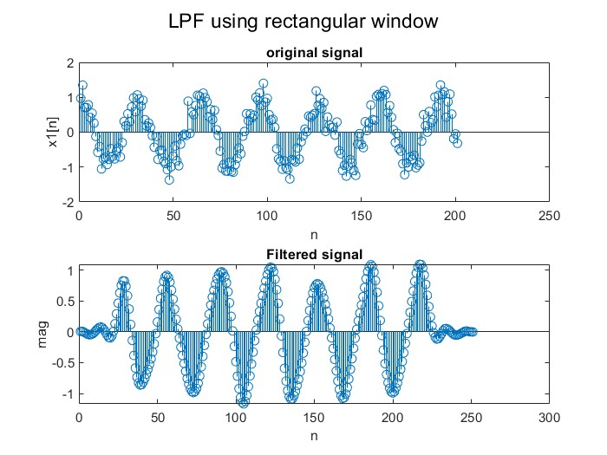

We can observe that the noisy signal is filtered and we get a cleaner output.

f) Changing the filter and then using it :

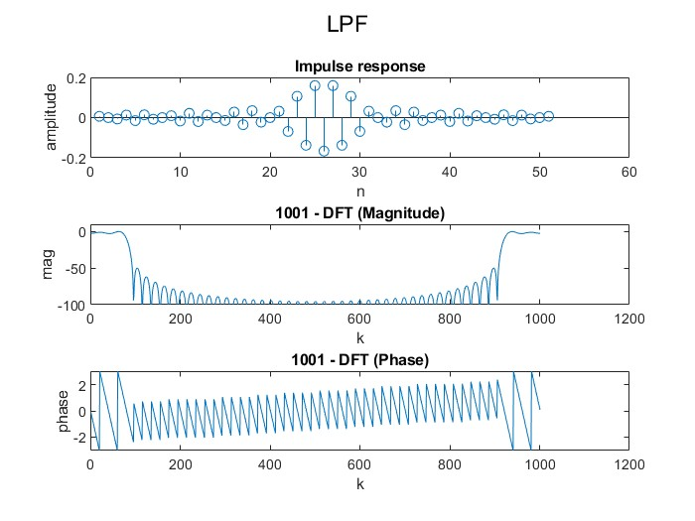

We can observe that the nature of the filter has changed and now it acts as a high pass filter.

**Question 2**

a) Frequency analysis of FIR notch filter :

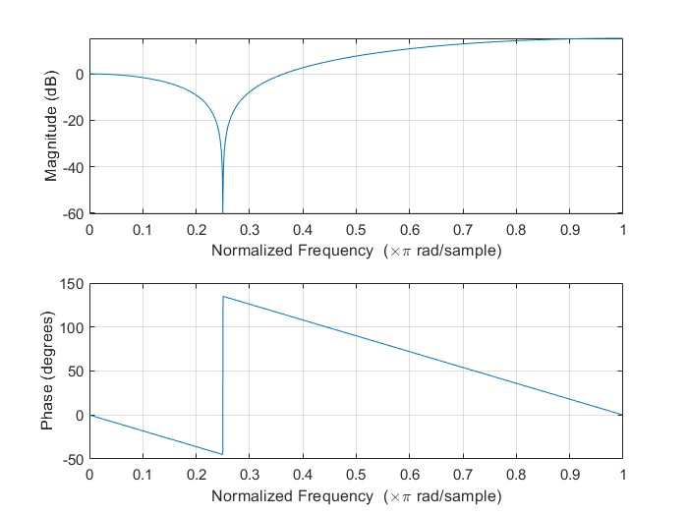

We can observe a zero at pi/4;

b) Frequency response of an IIR notch filter :

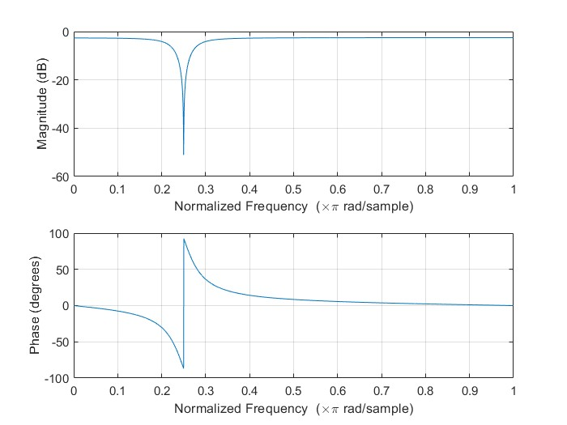

c)

* The FIR notch filter has an ROC that contains infinity, hence it is a causal filter and it is absolutely summable, which makes it stable too.
* The IIR filter contains poles inside the unit circle and has an outsided ROC which includes z = infinity. Hence this filter is causal and stable too.

The P-Z plots are given of the two filters :

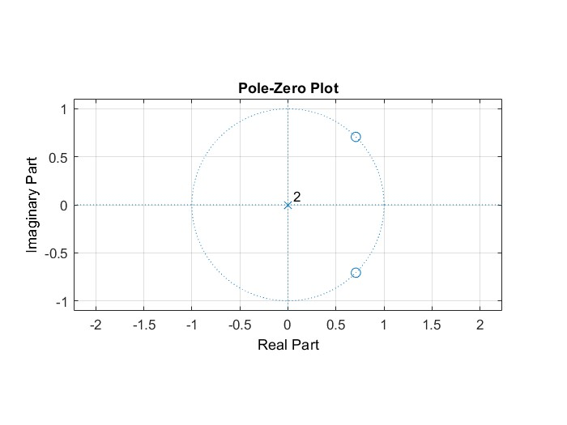 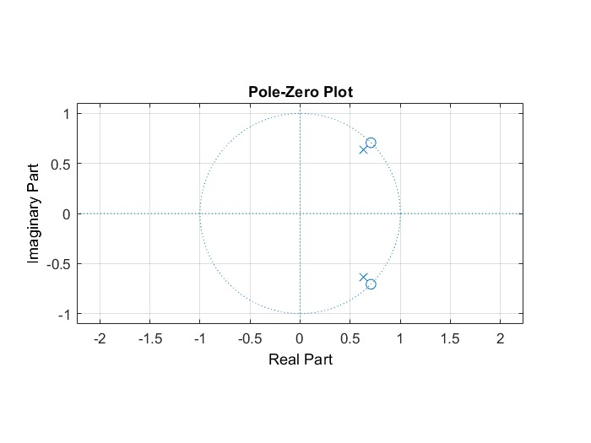

d) With change in the value of r, the precision of our filter changes. Precision increases with increase in the value of r.

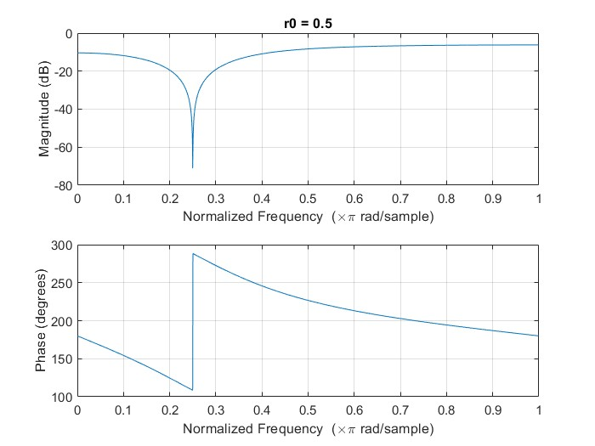 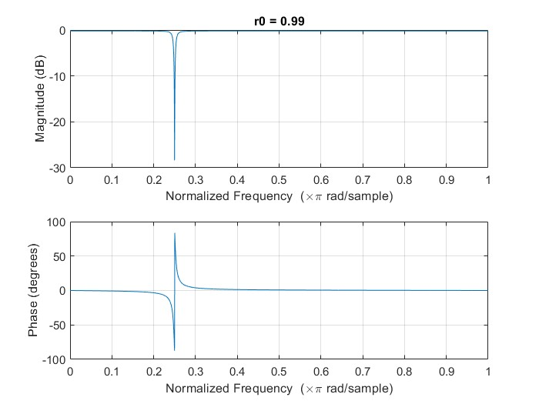

f) Plots of the handel sound file after filtering :

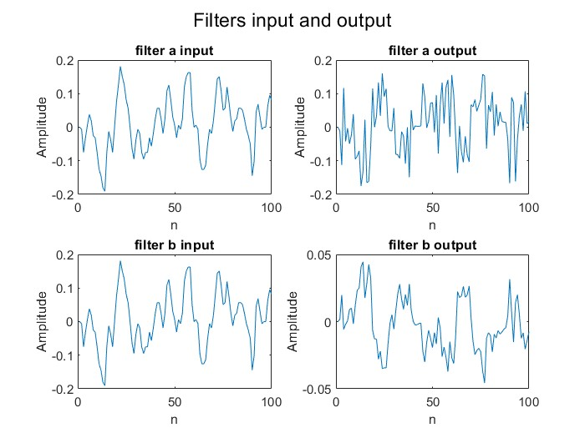

**Question 3**

In this question we examine filters using the inbuilt MATLAB tool filterDesigner

a) By choosing appropriate settings, we get the following filter :

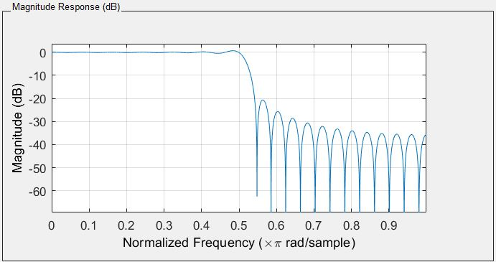

This is the low pass filter described in question 1.

B) Plotting the other responses:

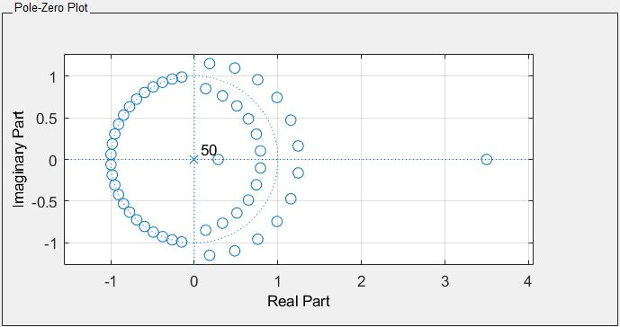 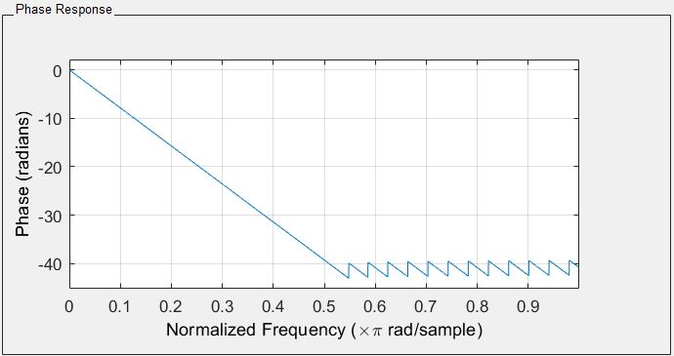

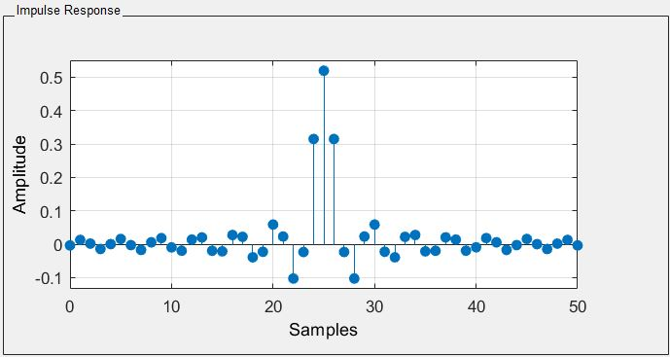

C) Designing the specified filter :

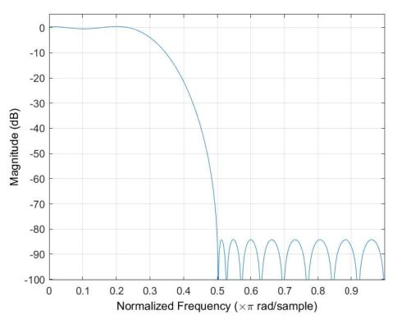

We can observe that this being an equiripple filter causes the ripples of the stop band to be of the same amplitude and that of the pass band to be of same amplitude.

D) When the design method is changed to least squares, we get the following filter :

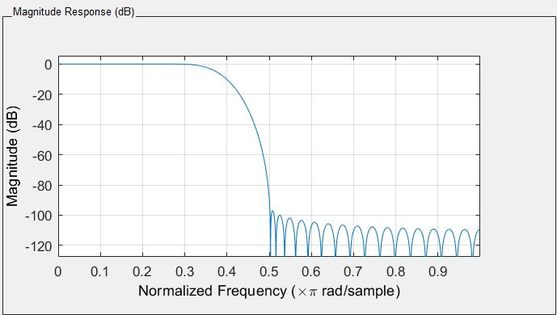

We can observe that the passband in the least squares method does not have any significant ripples and the stop band ripples (side-lobes) instead of having constant amplitude have decreasing amplitude.